TABLE OF CONTENTS

1. OPR Legend 2
2. List of Abbreviations 3
3. General Project Description 4
4. Project Objectives/Project Guiding Principles 4
5. Funding Plan 5
6. Project Budget 6
7. Project Schedule 7
8. Building Operations Information 8
9. Owner’s Directives and Special Project Requirements 9
10. Building Occupancy / Space Utilization Information 10
11. Applicable Codes, Standards and GT Reference Documents 12
12. Functional Requirements 13
13. Responsibility Matrix 14
14. Sustainability Requirements and Certification Goals 15
15. Indoor Environmental Quality Requirements 18
16. Utilities and Metering Requirements 19
17. Envelope and Systems Performance Requirements 20
18. Operations and Maintenance Expectations 25
19. Commissioning Process 27
20. Document Revision History 28

OPR Legend
OPR LEGEND
Black text: Generally known information with blanks to be completed
Black italic text: Example text for reference only
Green Text: Input required from Georgia Tech
Blue italic text: Info from GT Yellow Book
Red text: Requires input from the Design Professional.
Highlighted Text: Hyperlink to be added

List of Abbreviations
  - ADA: Americans with Disabilities Act
  - A/V: Audio-Visual
  - BECx: Building Envelope Commissioning
  - BOD: Basis of Design
  - CD: Construction Documents
  - Cx: Commissioning
  - CxA: Commissioning Authority
  - DBT: Design-Build Team
  - dB: Decibel Level
  - DD: Design Development
  - EUI: Energy Use Intensity
  - FC: Foot-Candle
  - FPT: Functional Performance Test
  - GC: General Contractor
  - GMP: Guaranteed Maximum Price
  - HVAC: Heating Ventilation and Air Conditioning
  - IT: Information Technology
  - M&V: Measurement and Verification
  - MEP: Mechanical/Electrical/Plumbing
  - NC: Noise Criteria
  - NDL: No Dollar Limit
  - OPR: Owner’s Project Requirements
  - PFC: Pre-functional Checklist
  - PM: Owner’s Project Manager
  - PV: Photovoltaics
  - RDS: Room Data Sheets
  - SCL: Stated Cost Limitation
  - SD: Schematic Design
  - STC: Sound Transmission Class

General Project Description
This Project involves the renovation and addition to the Campus Center that will in total consist of 300,000 square feet of new or updated space. The project delivery method is Design-Build and the selected team is Gilbane partnered with Cooper Carry and Workshop. This approach conceives of the Campus Center as an experiential path, from Clough Commons to the Campus Recreation Center, that is punctuated by a series of walks, plazas, richly articulated buildings, spatial experiences, and opportunities for social, creative, intellectual, and restorative engagement.

Project Objectives/Project Guiding Principles
  - Serve the entire Georgia Tech community
  - Provide locations to reset, restore & refuel
  - Showcase Georgia Tech’s brand and be a catalyst for creative expression
  - Foster friendships, bridge cultures disciplines & interests
  - Promote leadership, involvement and finding one’s niche
  - Activate Tech Green

Funding Plan
  - This project is a standard Public Private Venture (PPV) utilizing Georgia Tech Facilities, Inc. Georgia Tech's out of pocket costs for design and other project related expenses may be reimbursed by bond sale upon issuance.
  - The plan for debt service repayment is a shared cost of 25% from the Institute to support Resident Instruction space, 25% from Auxiliary Services (Dining and Retail), and 50% from new student fee revenue. The fee is approved to begin in Fall semester 2020, and is not to exceed $85 per semester.

Project Budget
  - Total Project Budget: $ 110,000,000

  - GMP (w/ design fees): $ 89,300,000

Project Schedule
Milestone | Begin Date | End Date
Design
Programming | April 2018 | June 2018
Schematic Design | May 2018 | August 2018
Phase 1 DD (Exhibit Hall/Meeting Shed) | August 2018 | November 2018
Phase 2 DD (Wenn Renovations) | August 2018 | January 2019
Phase 1 CD (Exhibit Hall/Meeting Shed) | November 2018 | February 2019
Phase 2 CD (Wenn Renovations) | January 2019 | May 2019
Construction
Phase 1 (Meeting Shed) | April 2019 | May 2020
Phase 1 (Exhibit Hall) | April 2019 | May 2020
Phase 2 (Wenn Renovations) | August 2020 | November 2021
Phase 1 Operational |  | August 2020
Phase 2 Operational |  | August 2022
Substantial Completion (both phases) |  | February 2022
Warranty
Phase 1 Seasonal Testing | Summer 2020 | Winter 2020
Phase 2 Seasonal Testing | Winter 2022 | Summer 2022
Phase 1 1-Year Warranty Expiration |  | February 2023
Phase 2 1-Year Warranty Expiration |  | February 2023

Building Operations Information
POC | POC Name | Email or Main Phone #
GT FM | John DuConge’ | John.duconge@facilities.gatech.edu
GT CPSM POC? | Amanda Jones | Amanda.jones@cpsm.gatech.edu
GT Program Manager | BDR Partners  John Barnes | John.barnes@bdrpartners.com
GT O&M (Area Mgr) | Area Manager  Jammie Gaines | Jammie.gaines@facilities.gatech.edu
GT End-User POCs
Aux Services | Director  Carolina Amero | Carolina.amero@gatech.edu
Dining | Staci Flores | Staci.flores@sodexo.com
Post Office
Student Center Admin | Director  Lindsay Bryant | Lindsay.bryant@stucen.gatech.edu
Student Center Facilities | SC Ops/Facilities  Marcus Mister | Marcus.mister@stucen.gatech.edu
Student Engagement | Gerome Stephens | Gerome.stephens@gatech.edu
WREK
OTHER
Design-Build POC | Brian Steed | bsteed@gilbaneco.com
CxA/M&V POC | CxA TBD
OTHER

  - Building Management: Student Center
  - Building Maintenance: [GT Area 1][Aux Services 3rd Party][Other]
  - Billable Entities:

Owner’s Directives and Special Project Requirements
  - Project Delivery Method
    - Design-Build
Design Builder | Gilbane
Architect | Cooper Carry
Architect | Workshop
MEP Consultant | Newcomb & Boyd
Others as needed

  - Requirements for the Design Professional (DP part of the Design-Build Team)
    - The Design Professional shall participate in the OPR development process through attendance at OPR Workshops facilitated by the CxA as well as by contributing feedback through reviews of the OPR document. The CxA will coordinate meetings in advance with GT and the Design Professional.
    - The Design Professional with collaboration with GT CPSM, shall produce comprehensive Room Data Sheets for the project and they shall be delivered to GT and the CxA ideally at the end of programming and no later than the end of Schematic Design. This requirement shall only be removed if GT agrees based on the nature of the project.
    - All design deliverables shall be per the GT Yellowbook, but also shall be setup in a Bluebeam session for review by GT and relevant team members including the CxA. This shall include the Energy Report, as required by the Yellowbook, at each major design milestone.
    - The Design Professional shall perform a partial-day page-turn for the O&M Staff at the end of:
      - Schematic Design
      - 100% Design Development
      - 75% (or 90%) Construction Document
This page-turn shall occur in parallel with the Bluebeam design review sessions for GT stakeholders with interest but not able to perform a drawing/specification review. This is expected to be more of a “fly-thru” to allow O&M staff to listen and provide important feedback.
    - Building Interior Mock-Up(s): [Yes or No]

  - End-User Directives
    - Example: The following food venues require 140ºF water for pot-washing which will need to be accounted for in the design, either centralized or localized: ABC Foods, XYZ Coffee,

  - Georgia Tech Standards Deviations
    - Example: Design Professional shall not be required to provide an energy model for the project given that this project is a renovation.

Building Occupancy / Space Utilization Information
  - Occupancy Table

Building/Floor | Life Safety Counts | HVAC Load Calculation Counts
Exhibit Hall
Meeting Shed
Wenn

  - Space Utilization Table

Building/Space Type | Occupied Hours
JULY 2018: REFER TO OPERATING SCHEDULE QUESTIONNAIRE BUILT BY THE ENGINEER AND POPULATED BY GT. CONDENSE QUESTIONNAIRE INTO THE BELOW TABLE AS A SUMMARY DURING SCHEMATIC DESIGN PHASE.
Exhibit Hall
Ballroom/Main Event
Pre-Function
Catering Kitchen
A/V Control Room
Catering/Dining Suite
Lounge
Meeting Shed/Pavilion
Meeting Rooms
Board Room
Catering Hub
Café/Coffee Shop
Lounge
Retail
WREK Radio
Admin Offices
Wenn
Meeting Rooms
Large Theater
Little Theater
Production Kitchen
Food Hall
Tech Rec Food Venue
Destination Restaurant B
Lounge (Indoor)
Post Office
Campus Store/Convenience Store
Kaplan
Paper and Clay
Under the Couch
Tech Rec
Student Resources
Student Resources Offices
Admin Offices
Welcome Center

Applicable Codes, Standards and GT Reference Documents
  - GT Yellow Book (October 2017)
  - GT Applicable Standards, Guidelines and Specifications (BIM, Low Voltage, Housing Standard, etc.)
  - GT Campus Master Plan
  - The 2012 International Mechanical Code, with Georgia amendments (2014)(2015)
  - The 2017 National Electrical Code, with no amendments
  - The 2012 International Fire Code, with Georgia amendments (2014)
  - The 2012 International Fuel Gas Code with Georgia amendments (2014)(2015)
  - The 2012 Edition International Energy Conservation Code, with Georgia Supplements and Amendments (2011)(2012)
  - NFPA Code as adopted/modified by Ga State Safety Fire Commissioner
  - ASHRAE 189.1-2014
  - Energy Efficiency and Sustainable Construction Act of 2008 (SB 130).
  - Georgia Accessibiity Code
  - ASME A17.1-2013 Safety Code for Elevators/Escalators with Georgia amendments
  - ASHRAE 52.2-Year – Ventilation for Acceptable Indoor Air Quality
  - ASHRAE 55-Year – Thermal Environmental Conditions for Human Occupancy
  - ASHRAE 62.1-Year Ventilation for Acceptable Indoor Air Quality
  - SMACNA "HVAC Duct Construction Standards, Metal and Flexible ", Third Edition, 2005, latest printing as published by SMACNA.
  - WELL Building Standard v2 (Comply with standard, but do not certify)
  - GT Strategic Plan for Sustainable Practices

Functional Requirements
  - For most information, refer to the Room Data Sheets (partial sheets currently from Programming Document).
  - RDS shall cover all the major functional requirements for spaces. Expect information captured in the Room Data Sheets to include: utilization, temp/RH ranges, lighting levels, acoustical expectations, etc.

Responsibility Matrix
  - This matrix is intended to capture responsibilities where overlap or separation occurs between GT and Gilbane. This matrix is not intended to represent the OFCI matrix that Gilbane is expecting to include in the design documents for equipment. GT shall take the lead on populating this matrix with input from DBT.
Item | GT | Gilbane | Remarks
Kitchen Equipment |  |  | Reuse where possible, Gilbane to furnish install new as needed. Include matrix in DDs to capture re-use versus new.
Wireless design
A/V Equipment | X |  | GT to provide A/V equipment. Gilbane to provide cabling and power to equipment and control panels.
Patch Cabling
Access Control
WREK Radio | X |  | Radio equipment to be re-used or new if needed, purchased by WREK. Gilbane to provide power, data, etc. to equipment and appropriate space to house the equipment (closets, shelving, etc. may be required).
OTHER

Sustainability Requirements and Certification Goals
  - Energy and Water Performance Criteria
    - Energy Use Intensity (EUI) target: 55 to 75 kBtu/ft2-yr (see below) which shall be tracked utilizing the energy modeling process during the design phase and validated post-occupancy through the M&V process which is led by the CxA.
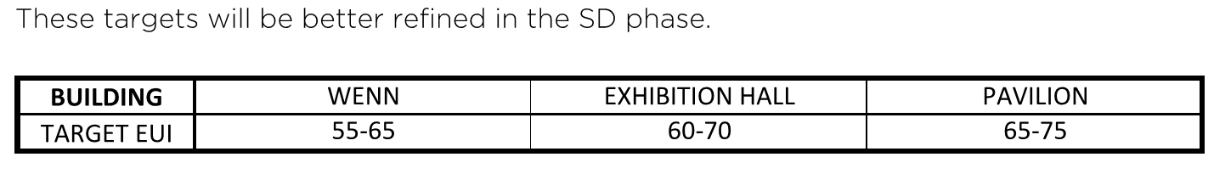
    - The energy model shall be the responsibility of the Design Professional and the energy modeling software that shall be used is EnergyPlus. The consultant shall be responsible for delivering the model file to GT at each design iteration to include the input data.
    - PV-readiness required for:
      - Wenn? Required by ASHRAE 189
      - Exhibit Hall?
    - Water use requirements:
      - Example: Low flow fixtures per the Yellow Book
      - Example: HVAC condensate shall be diverted to cistern

  - Building Life Cycle Requirements
    - Building Life Expectancy (Materials and systems shall be selected accordingly):
      - Wenn: 50 Years (institutional)
      - Exhibit Hall: 30 Years (medium weight)
      - Pavilion: 20 Years (light weight)

  - Other Sustainability Requirements
    - Green Building Standard Pursuits
      - ASHRAE 189.1-2014: DBT proposes compliance as follows
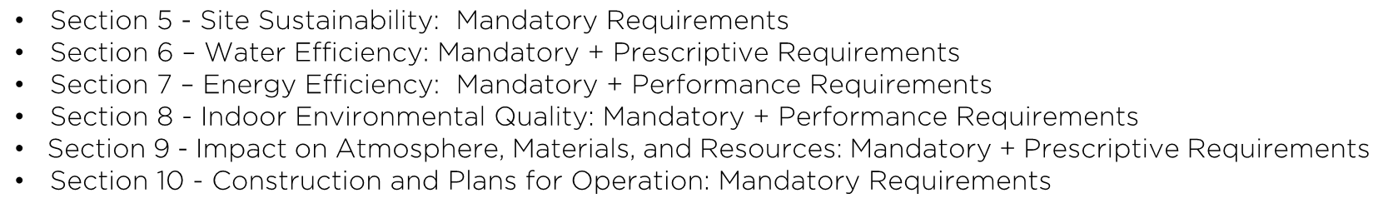
      - WELL v2: Comply with, but do not certify
        - DBT responsible for preparing WELL scorecard and tracking all requirements, producing necessary paperwork
    - GT Sustainability Checklist Requirements
      - Refer to the project Sustainability Checklist below
      - GT to consider updates as necessary during SDs
      - UPDATE TO TABLE BELOW: Intent for rainwater capture/cistern is that the project plan for connections from project systems to other regional (campus) cisterns
      - UPDATE TO TABLE BELOW:
        - Goal: Achieve zero waste
        - Applies: YES
        - Comments: 95% diversion of waste from landfill, goal set by the Strategic Plan for Sustainable Practice. Note: This was also a goal of west village
- UPDATE TO TABLE BELOW: Submetering by department? Address under Metering section, but discuss details.
- UPDATE TO TABLE BELOW: Do other modes of pedestrian transportation need to be considered given comment from Office of Sustainability?
- CONSIDER AN UPDATE TO THE SUSTAINABILITY CHECKLIST OVERALL.
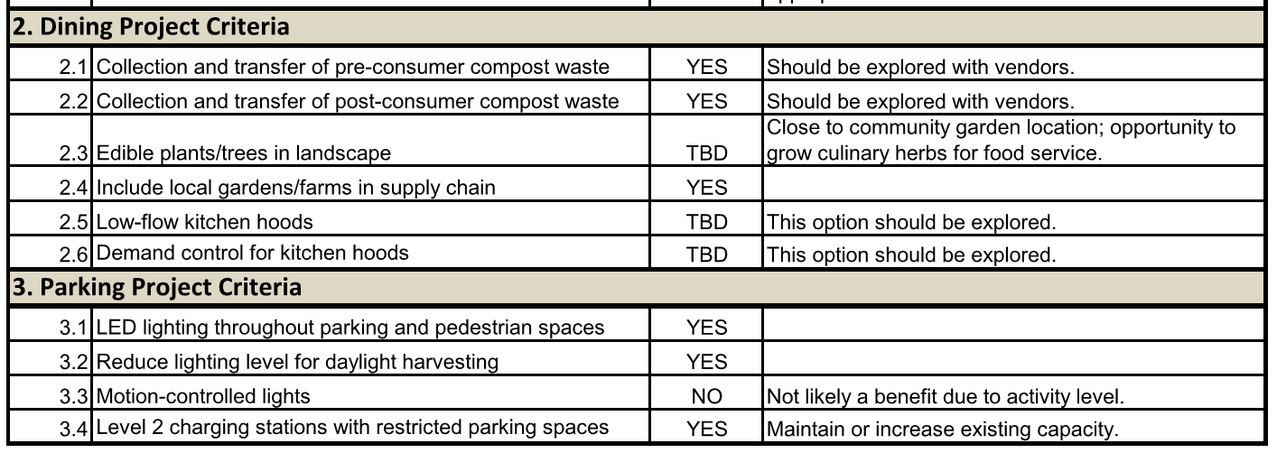

Indoor Environmental Quality Requirements
  - Are there special requirements for Indoor Environmental Quality
    - WELL v2 expected to driving factor for IAQ requirements
  - Temperature and Humidity
    - Refer to the GT Yellow Book Section 230003 (reference version stated under Section XI of this OPR document)
    - Record project-specific requirements deviations to the 230003 requirements:
      - Space/Area 1
      - Space/Area 2
    - Minimum humidity: ____ % RH (delete if not applicable)

  - Ventilation Requirements
    - Meet the requirements of ASHRAE 62.1-2013 as required by the Yellowbook.
    - Demand Control Ventilation: Yes, for all densely-occupied spaces (shall be consistent with ASHRAE 62.1-2013 along with DCV permitted in ASHRAE 90.1-2014
      - Ballroom
      - Board Rooms
      - Meeting Rooms
      - Large and Little Theaters
      - Other dense-occupied spaces as needed
    - Deviations from Yellowbook
      - Design team to coordinate with GT for areas that could be considered for loosening of temperature/humidity requirements.

  - Acoustics

Space Type | Noise Criteria (max) | Wall STC
General Open Office | 40
Private Offices | 35
Lobbies and Common Areas | 45
Meeting Spaces (Board, Huddle) | 35
Classrooms | 30
Distance Learning Classrooms | 25
Kitchens | 45
Dining Areas | 40
Theatres | 30
Practice Rooms | 35
Recording and Control Rooms | 25
Radio Studios | 25
Main Event Spaces | 35
    - Acoustical Field Testing Requirements Yes for Event Spaces. Discuss exact spaces to be tested.

Utilities and Metering Requirements
  - Utilities
    - Tie-in to existing utilities for use on the project shall be assessed during Programming, finalized during SDs. Utilities to be considered and the tie-in requirements shall be documented here (campus chilled water, campus steam, natural gas, domestic water, etc.).

  - Metering
    - The Design Professional shall include in the design documents a one-line metering diagram for all project meters with a meter schedule on a single sheet. This shall include not only power meters but also gas, water, submeters and other components that are to be used as a metering tool for M&V purposes (i.e. variable frequency drives).
    - M&V Plan Required: Yes
      - The CxA shall be responsible for development of the M&V Plan which shall be submitted as first draft for initial review at the same time as the 100% DDs. M&V Plan to be issued at the same time as 100% CDs. Updates to be produced when/if changes are made to the design documents impacting the metering approach.

Envelope and Systems Performance Requirements
  - Envelope
    - From Program Doc: Material and systems choices will support a long-life, loose-ft preferred by Georgia Tech. These choices will refect a range of life spans: from five (5) to 50 years. Construction types for the new Campus Center will range from institutional-quality renovations to medium and lightweight tactical structures. The buildings have the potential to be designed in a manner that refects the temporal nature of their construction types as well as the programs within them. For example, the Wenn renovation and the Student Life Pavilion are better suited to an architectural expression which is more enduring. Tactical structures, on the other hand, could incorporate a spectrum of construction types: from inflatables, food trucks and shade canopies to lighter structures – such as a shipping container painted Buzz Gold, or small wood structures set amongst the trees for refection and contemplation.
    - Division 7 (Refer to Yellow Book Div 07 Sections for standard expectations for building envelope requirements)
      - Project-Specific Yellow Book Modifications (as applicable by building for Wenn, Exhibit Hall, Pavilion)
        - Waterproofing
        - Air barrier
        - Vertical thermal insulation
        - Roofing
      - Alternates
        - Example: Roofing on tactical building(s) shall be permitted to utilize mechanically-fastened TPO roofing system.

    - Division 8 (Refer to Yellow Book Div 08 Sections for standard expectations for building envelope requirements)
      - Project-Specific Yellow Book Modifications (as applicable by building for Wenn, Exhibit Hall, Pavilion)
        - Storefront
        - Curtainwall
        - Entrances
      - Alternates
    - Mock-up requirements
      - Stand-alone: Yes
        - Stand-alone mock-up shall be required for:
          - Institutional versus tactical side-by-side to be confirmed. Construct mock-ups for re-use by GT students/staff (e.g. shelter, bike hub, dog stop)
          - Exhibit Hall
          - Wenn Addition
      - In-place
        - Architect shall propose no later than DDs the intended in-place mock-ups that shall be reviewed as “first-of-kind” including pertinent quantities (i.e. 100 linear feet of below-grade waterproofing).
    - Testing requirements
      - Testing to be performed under the scope of the Commissioning Authority.
      - Waterproofing
        - ASTM D4138
          - Sample strategy:
      - Air barrier
      - Sealants
        - Adhesion testing
      - Storefront and Curtainwalls
        - AAMA 502.1
          - Sampling strategy:
        - ASTM E1105
          - Sampling strategy:
      - Roofing
        - ASTM D7877
        - ASTM D5957
          - Sampling strategy:
    - Roof and Wall Bond Required [YES or NO]

  - Equipment
    - Equipment Responsibility
      - The Design Professional shall produce a matrix to be included in the design documents that indicates the requirements for furnishing and installing of equipment. This shall include equipment, locations, power requirements, loads (w/sf), etc. Coordinate with GT applicable end-users on all existing equipment that is being re-used for the project and include in the matrix as well.
    - Other Equipment (add all as applicable)

  - Vertical Transportation (Refer to Yellow Book Section 142000 for standard expectations for elevators)
    - Wenn
    - Exhibit Hall
    - Pavilion (delete if not applicable)

  - Fire Protection (Refer to Yellow Book Div 21 Sections for standard expectations for fire protection)
    - Project-specific Yellow Book modifications
      - Wet-Pipe
      - Dry-Pipe (delete if not applicable)
      - FM-200 (delete if not applicable)
    - Alternates

  - Plumbing (Refer to Yellow Book Div 22 Sections for standard expectations for plumbing systems)
    - Project-specific Yellow Book modifications
      - Wenn
      - Exhibit Hall
        - Example: PVC allowed for use for above and below-grade sanitary piping
      - Paviliion
    - Alternates

  - Intelligent Building System/Fault Detection and Diagnostics
    - Georgia Tech expects that FD&D will be incorporated into the project with specifics to be discussed. OPR session discussion item

  - HVAC (Refer to Yellow Book Div 23 Sections for standard expectations for HVAC systems)
    - The mechanical engineer shall document the lighting power density assumptions in the Basis of Design document.
    - Project-specific
      - Wenn
      - Exhibit Hall
      - Pavilion
    - Building automation: Sole-source to Johnson Controls
    - Other mandates
    - Alternates

  - Electrical (Refer to Yellow Book Div 26 Sections for standard expectations for electrical systems)
    - Project-specific
      - Wenn
      - Exhibit Hall
      - Pavilion
    - Other mandates
    - Alternates

  - Fire Alarm (Refer to Yellow Book Div 28 Sections for standard expectations for fire alarm systems)

  - Security/Access Control (Refer to Yellow Book Div 28 Sections for standard expectations for security and access control)

  - Audio-Visual
    - Refer to GT Low Voltage Standards
    - Deviations from the GT Low Voltage Standard (if applicable)

  - IT Requirements
    - Refer to GT Low Voltage Standards
    - Deviations from the GT Low Voltage Standard (if applicable)
      - Wenn
      - Exhibit Hall
      - Pavilion

  - Renewable Systems
    - Project-specific
      - Wenn
      - Exhibit Hall
      - Pavilion

  - Site Requirements
    - Cistern (if applicable)
    - Irrigation/Controls (if applicable)
    - Greywater (if applicable)
    - Blackwater (if applicable)
    - Constructed Wetlands (if applicable)

Operations and Maintenance Expectations
  - Owner Training Requirements
    - Refer to Yellow Book Section 017900 for general training expectations
    - The DBT shall produce a dedicated Owner Training specification (017900, Demonstration and Training) during the SD phase (outline spec). Update this spec at 100% DDs and finalize in CDs. In addition to the requirements of the Yellow Book specification shall include:
      - Hours per discipline or as a “bucket” of hours for all systems to be determined with GT after finalizing systems.
      - GT requirements specific requirements by building/systems (max session lengths, sign-in/sign-out, end-user training sessions, etc.)
      - The DBT shall coordinate with GT and the CxA to finalize the details of this specification based on each building and associated systems (tailor the scope to the actual needs).

  - Equipment Access Requirements
    - Wenn
      - Example: Central station AHUs shall include no less than 24” access doors into the fan and cooling coil sections. The fan section shall include a viewing window.
    - Exhibit Hall

    - Pavilion
      - Example: If elevator to the roof is not provided, an interior ladder to the roof shall be provided with safety cage.
      - Example: Davit arm(s) shall be required to allow for removal of large components from roof-mounted equipment (i.e. compressors, fan motors). Coordinate location for aesthetics.

  - Temporary Operation of Permanent Systems
    - The DBT shall produce a summary specification regarding the allowance of temporary use of permanent building systems. If the permanent building systems are to be used (i.e. temporary conditioning), the DBT shall produce a Temporary Conditioning Plan during early construction detailing the intended use of equipment, how look it will be used, how it will be protected, etc. This Plan shall be formally submitted for review and comment by GT and the CxA.
    - Refer to Yellow Book Section 013546 (IAQ Scheduling/Sequencing) for additional information specifically regarding indoor air quality during construction.

  - Special Warranty and Bond Requirements (update through design for applicability)
    - Roof and Wall Bond: 5 years
    - Roofing: 30 years NDL (20 years as deductive alternate)
    - Chillers: 5 years (all components) / 10 years (compressors)
    - Condensing Boilers:
    - Rooftop Units:
    - Add as applicable (as design develops)

  - Service Agreements (if applicable)
    - Example: Generator(s)

  - Post-Construction Contact Information
Point of Contact (POC) | Name | Email or Phone Number
GT FM | John DuConge’ | John.duconge@facilities.gatech.edu
GT CPSM POC | Amanda Jones | Amanda.jones@cpsm.gatech.edu
GT O&M (Area Mgr) | Jammie Gaines | Jammie.gaines@facilities.gatech.edu
GT End-User POCs
Student Center | Lindsay Bryant | Lindsay.bryant@stucen.gatech.edu
CxA | TBD

  - Warranty Phase Communication Protocol

Commissioning Process
  - Design Phase

  - Construction Phase

  - Acceptance Phase

  - Occupancy Phase

  - Measurement & Verification

  - Systems to be Commissioned (to be detailed after CxA selection)
    - Building Envelope
    - HVAC Systems (including HVAC Controls)
    - Plumbing Systems
    - Electrical Systems (includes fire alarm, emergency power, access control)

  - Sampling Procedures

Document Revision History
Revision | Date
Draft | June 26, 2018
Revision 0 | July 17, 2018
Revision 1
Revision 2

POST-PROGRAMMING ADDITIONAL QUESTIONS/DISCUSSION ITEMS
These are not organized by priority level
- Info required from DBT on the Room Data Sheets
- Occupied hours for various space types (right now appears at 6 am to 10 pm for all). (July 2018 Update: Occupancy Schedule Questionnaire submitted by N&B and responded to by GT and is attached to this version of the OPR for reference)
- How are the non-GT dining vendors being built out? As part of project?
- Metering – Don’t wait for this discussion given the amount of 3rd party vendors that appear to be occupying Wenn. Metering needs could be significant.
- O&M needs between institutional versus tactical buildings.
- Pros and cons of HVAC options for buildings, particularly Exhibit Hall and Pavilion.
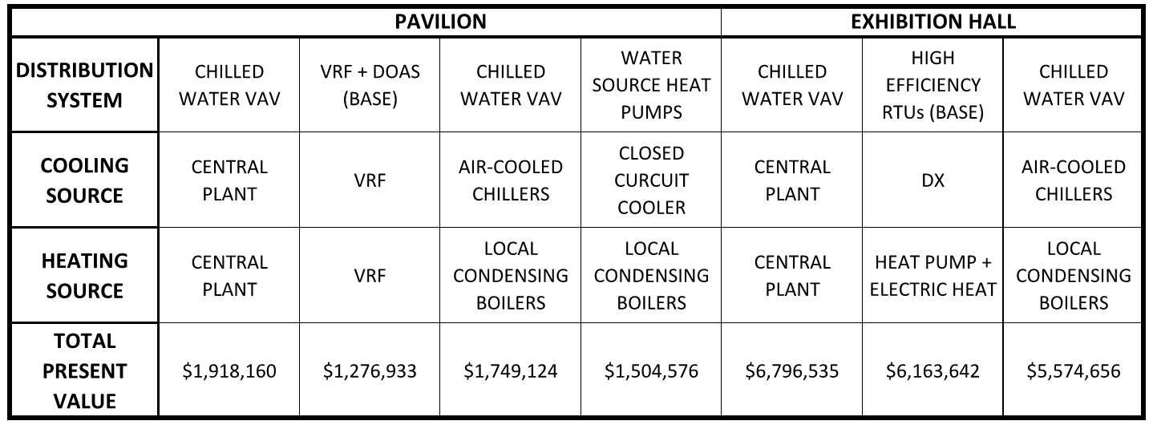
- Mock-up requirements (including institutional and tactical and permanent function)
- Equipment and components responsibility matrix (OFCI, OFOI, etc.)
- Documenting compliance with ASHRAE 189
- IAQ expectations – driven by pursuit of WELL? Who will be responsible? Consult with GT EH&S as well.
- Envelope testing requirements – to be in CxA scope, need to define tests and quantities.
- Energy code to be used (90.1 vs IECC and version date) – open question from DBT
- Where, if any, will acoustical testing be required? Theatre spaces? Recording studio? If so, needs to be added to project scope and determine who’s responsibility.
- FD&D – Included in the project budget at this time? GT FD&C preference on new capital projects has been to include FD&D into the project. GT will need to decide if/how to include in the project and coordinate with the DBT.

